4th Grade – Greek Language

Name: ………………………………… Section: ……………

ΗΟΜΕWORK 6

Dear scholars,

Please print the homework packet and complete it. The homework packet is due on 12/04 /2020.
QUIZ will be taken on WEDNESDAY 30/04/2020.

Dear parents,

Please encourage your child to complete the homework on time and to study for the QUIZ. Please remind them to upload the Homework packet on Archie, on Friday 12/04/2020.
Ιf you have any questions or concerns, please feel free to contact me at: evgenia.kallimorou@archimedean.org

Thank you,

Mrs. Evelina Antonopoulou Kallimorou.

HOMEWORK_6
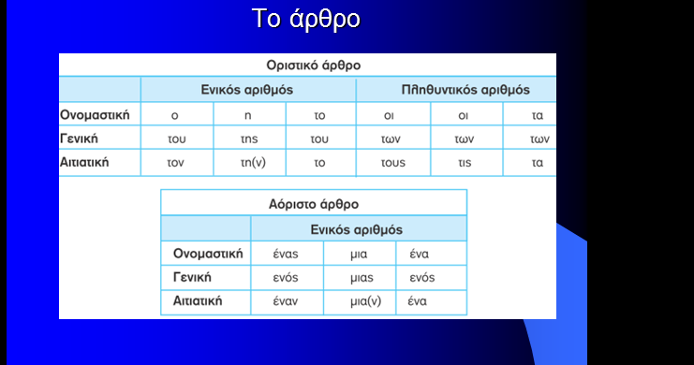

- Fill in the blanks with the indefinite article «ένας, μία, ένα».

